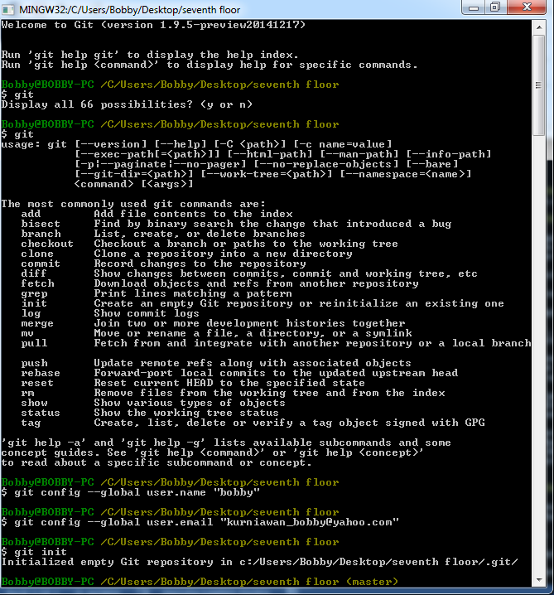

Image 1

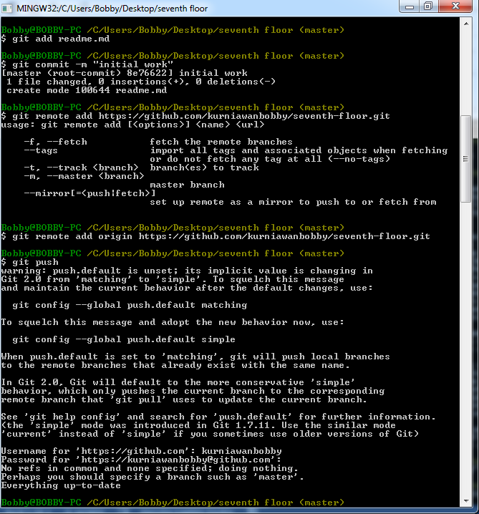

Image 2

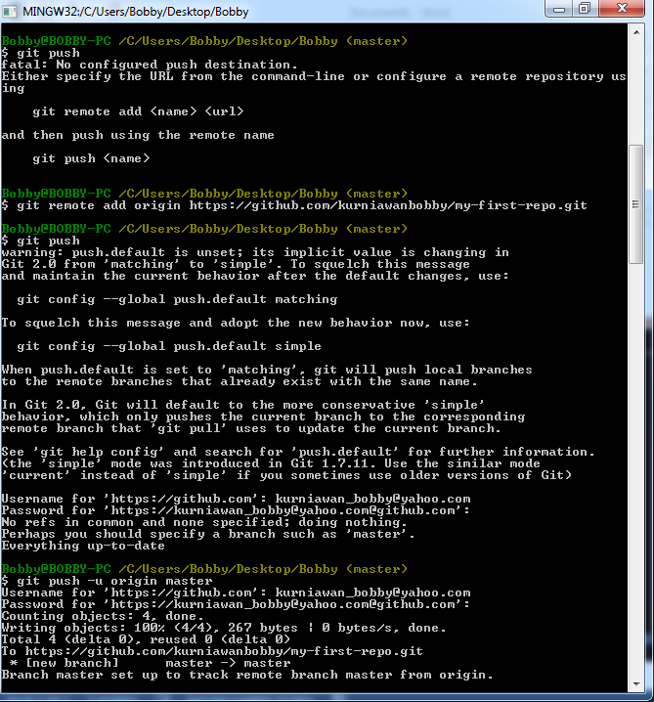

Image 3

**Code:**

Git clone <address> *for the initial repo we don’t need the <address>

//Git init *only use for initial

Git add . or Git add <file name>

//Git remote add origin <address> *only use for initial

Git commit –m “your word”

Git push

//Git push –u origin master *only use for initial